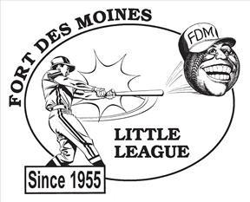
FORT DES MOINES LITTLE LEAGUE
P.O. BOX 35361
DES MOINES, IA 50315

Dear Supporter of Fort Des Moines Little League,

Although baseball season is still months away, we here at Fort Des Moines Little League are in full swing of gearing up for our next season! The coaches and volunteers at FDMLL are committed to developing our participating youth by instilling teamwork, commitment, respect and hard work, all while teaching them the fundamentals of baseball. But we cannot do this without your help.

Sponsorship is a crucial part of our organization. The money raised helps us cover the cost of uniform, equipment, umpires, field maintenance, scholarships, and many other costs associated with running a quality program. Fort Des Moines Little League would like to invite you to become part of our fantastic program and ask for your support.

Attached you will find the sponsorship form with the various levels of participation. Please keep in mind that your donation will continue to allow us to offer an affordable program to our youth and allow families who cannot afford for their child to participate a chance to play. Plus, your donation is 100% tax deductible as we are a 501(c)3.

We want to thank you for your continued support of Fort Des Moines Little League and hope you will consider sponsoring our great program! We hope to see you around the ball fields this summer!

Sincerely,

Fort Des Moines Little League

FDMLL Sponsorship Form

Fort Des Moines Little League is a 501(c)(3) Non-Profit Charitable Organization and donations are tax deductible (EIN 23-7006448).

⬜ The Single $300
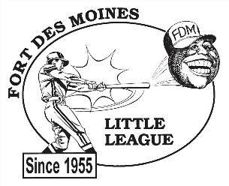
- Business name on one team’s jerseys
- Company thanked during daily announcements

⬜ The Double $550
-Business name on one team’s jerseys
- 3'x6' color banner on outfield fence
- Company’s name thanked during announcements
- Name and link listed on homepage fdmll.org

⬜ The Triple $800.00
- Business name on two team’s jerseys
- 3'x6' color banner on outfield fence
- Company’s name thanked during announcements
- Name and link listed on homepage fdmll.org

⬜ The Home Run $1,250.00
- Business name on three team’s jerseys
- Dedicated field with 4x8 banner on backstop fence stating:
“Welcome to (Company Name) Field”
- 3'x6' color banner on outfield fence
- Company’s name thanked during daily announcements
- Name and link to company homepage listed on fdmll.org

⬜ The Grand Slam $5,000.00
- Business name on four team’s jerseys
- Dedicated field with 4x8 banner on backstop fence stating:
“Welcome to (Company Name) Field”
- 3'x6' color banner on multiple outfield fences
- Company’s name thanked during daily announcements
- Name and link to company homepage listed on fdmll.org
- Name on ‘Top Sponsors of the season’ plaque that will be on display at the concession stand permanently

⬜ The Grounds Crew $300.00 - $5,000.00
- Provide a service for the ball park (can be a one time instance or for the full season)
- Receive appropriate level of benefits from above based on service provided

Sponsor Information:

Company Name______________________________________________________________
Address____________________________________________________________________ City________________________________ State_____________Zip Code_______________
Business name as you would like it to appear on jerseys:_____________________________
If you would like your name on a specific players team, please list player and team name (if available) here: __________________________________________

Contact person for advertising information (logos, banner info, etc.):
Name__________________________________Phone#______________________________
Email_______________________________________________________________________
Website Address______________________________________________________________

Please email or mail the completed form to FDMLL by March 1st.
fdmlittleleague@gmail.com or PO Box 35361 Des Moines, Iowa 50315
Payments may be mailed or sent via Venmo @FortDesMoines-LittleLeague-1

If you have any questions or wish to discuss further opportunities, please email fdmlittleleague@gmail.com

